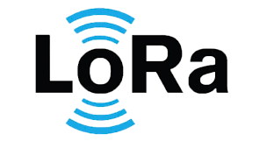**MatriX**

# 

# 

# 

| **Revision History** | | | |
| --- | --- | --- | --- |
| **Version** | **Changes** | **Date** | **Author** |
| V1.1 | Initial draft | 16/09/2024 | Keerthi Mallesh |

# 

# 

# Table of Contents

**Table of Contents 2**

**1. Abstract: 3**

**2. Purpose: 3**

**3. Areas of implementation: 3**

**4. Block Diagram: 4**

**5. Requirement: 4**

**6. Design and Software implementation: 5**

**7. Implementing LoRa Mesh: 5**

**8. Implementing the MQTT- 6**

**9. Flowchart 7**

**10. Reference documents 7**

# 

# 

# 

# Abstract:

LoRa is a popular communication technology in the Internet of Things (IoT) domain, providing low-power and long-range communications. Most LoRa IoT applications use the LoRaWAN architecture, which builds a star topology between LoRa end nodes and the gateway they connect to. However, LoRa can also be used for the communication between end nodes themselves, forming a mesh network topology.

# Purpose:

The requirement of the LoRa device and creating the LoRa Mesh using the available devices in the range gives the advantage of communication with less power and extracting all the information required. Very much useful in remote locations where the internet connection is negligibly slow. This tech comes into the picture where advancement in technology can be seen in reliable and independent products.

# Areas of implementation:

Can be implemented in the modern urban development system where the street lights can be created by the lora mesh network, which notifies the concerned people when the street lights face any issues.

Can be used in the cargo ships to check the container lockage.

Can be implemented for military use to find the exact location.

Can be used in the large warehouse to check if any goods are missing.

Can be installed in the traffic monitoring system to find the exact speed of the vehicle.

Can be used as a modern device for communication in the place of walkie-talkie where this is more secure and does not require government norms for communication.

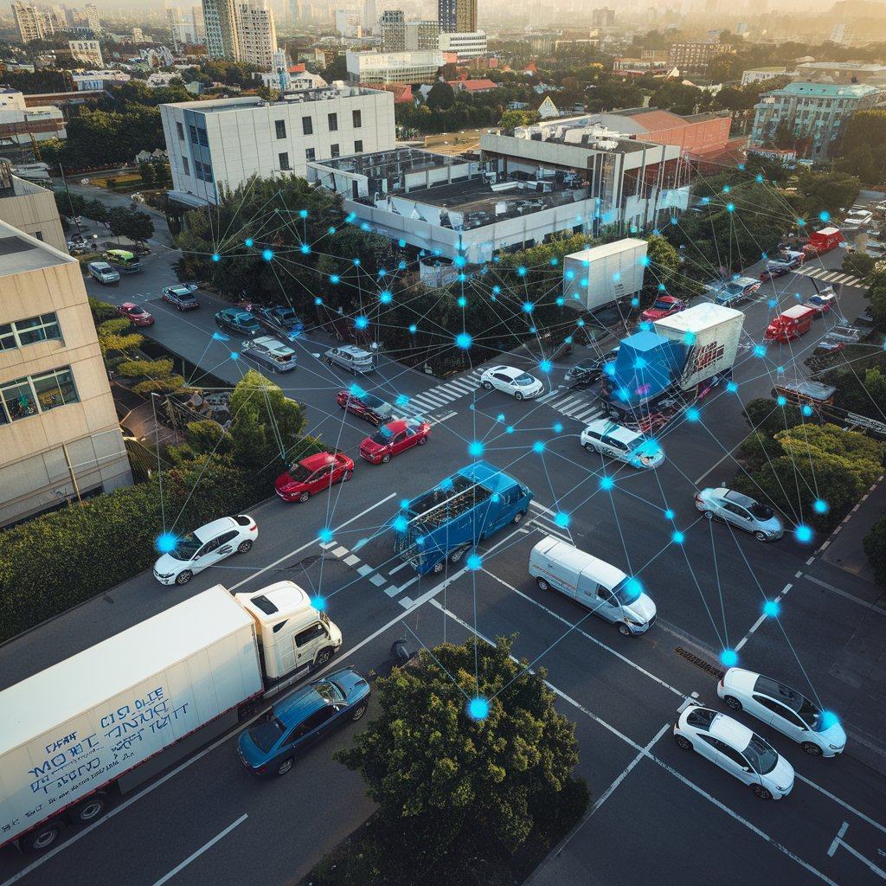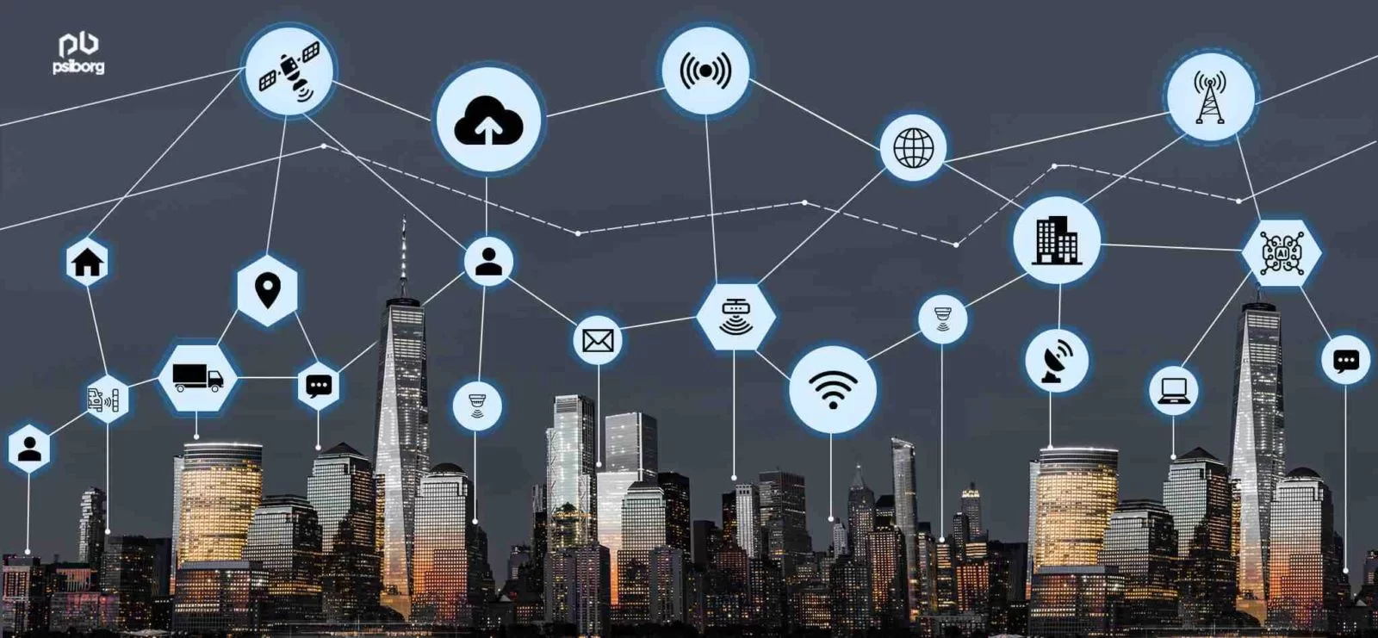

Lora can be used for a wide range of devices and the areas of implementation are limitless.

# Block Diagram:

## 4.1 Accelerometer Sensor(KXTJ3-1057) -

The KXTJ3-1057 is a 3-axis accelerometer manufactured by Kionix. This accelerometer is designed to measure acceleration in three axes (X, Y, and Z) and is commonly used in various applications, such as mobile devices, wearables, and industrial equipment, to detect motion, orientation, and vibration.

Specification:

Operating Voltage: 1.7V to 3.6V

Operating Temperature Range: -40°C to +85°C

Communication: I2C or SPI

Resolution: Up to 14 bits

Measurement Range: ±2g, ±4g, ±8g, ±16g

Low Power Mode: Supports various low-power operating modes for energy-efficient performance.

## 4.2 Semtech LoRa chip(LLCC68) -

The LLCC68 is a highly integrated Sub-GHz RF (Radio Frequency) transceiver chip developed by Semtech. The LLCC68 is optimized for low-cost applications and is primarily used for communication in the unlicensed ISM (Industrial, Scientific, and Medical) frequency bands. The LLCC68 is designed for ultra-low-power applications. In addition to LoRa, the LLCC68 supports FSK (Frequency Shift Keying) modulation.

Specifications:

Modulation: LoRa, FSK, (G)FSK, MSK

Frequency Range: 410 MHz to 810 MHz

Sensitivity: Down to -129 dBm (LoRa mode)

Output Power: Programmable, up to +22 dBm

Power Supply: 1.8V to 3.7V

Operating Temperature: -40°C to +85°C

Data Rate: LoRa mode: 0.018 kbps to 62.5 kbps || FSK mode:1.2 to 300 kbps

Current Consumption: Transmit(22 dbm ): ~130 mA || Receive (LoRa): ~4.6 mA

Standby: 1.5 µA

## 4.3 ESP32-WROOM 32E -

The ESP32-WROOM-32E is a highly integrated Wi-Fi and Bluetooth module from Espressif, widely used for Internet of Things (IoT) applications due to its low power consumption, high performance, and rich set of features.

While the MQTT feature is used, WI-FI is used which will be in station mode once the WI-FI is connected to the broker it will publish the information.

# Requirement:

Using the ESP32 and LoRa llcc68 chip need to design a LoRa mesh network where all devices in the range should be connected and share the information as mentioned and after that the table which has all the information related to the mesh network should be published to the MQTT broker server when a device of different type meaning which does not belong to the same network and does not belong to the same type or any non Lora device which can be subscribed to the broker can see the information.

# Hardware and Software Design:

* Developed the hardware using lora llcc68 chip and accelerometer sensor embedded with ESP32.
* Developing the software in Espressif IDF in C language.

# Implementing LoRa Mesh:

Initially started with a simple ping-pong example, referred to some published papers on the Lora mesh and also referred to some of the open source projects in GITHUB.

For our requirement the features which are needed is MQTT server implementation and creating a multiple node communication, so that implementing the lora mesh will be easier going further.

* Implementing the multi-node communication -

For implementing multi-node communication, things needed are node which acts as Master and requests the data of some device, the easy method for doing so is multi-hop method, Where the request information is transmitted if the device is not in range then device of same type receives the request and process the information retransmits the request from master so that the requested device if in range receives the information and process that and sends the acknowledgement and information requested, this process goes on until master reaches the destination node.

* Implementing the short route mechanism -

For implementing the short route mechanism, focus on the RSSI i.e. (received signal strength indicator) of the nodes to send information within the mesh network, based on the signal strength one can calculate the short route.

* Implementation of the Routing Table -

Initially before implementing the routing table, let’s understand the importance of it, the core importance of the mesh network is all the devices data can be accessed by network device so implementing the routing table dynamically cannot be done through array so linked list need to be implemented so that routing table has all the information of the device which is connected to the network and keeps on updating over the time frame.

* Implementation of LoraMesher algorithm -

All the devices will start as a receiver mode and have a small window for transmitting the information stored in the routing table so based on the number of nodes available the routing table will be updated dynamically. In the receive mode, received information will be processed and checks if this node is created or not, if not it creates a new node and updates the routing table. The features that are currently available are:- create node, delete node, add node, display node, find device.

# 8. Implementing the MQTT-

Here, MQTT(Message Queuing Telemetry Transport ) can be explained as, consider a Broker which has the information published by the topic and whoever accesses the server can see the information by subscribing to it. Here the broker server is eclipseprojects.io and the port number is 1883. The accelerometer data, device EUI ID, RSSI, SNR information is published in this case and can be seen in the other device by connecting to the same WI-FI or by accessing the server through MQTT explorer application. Need to change the broker server going further.

# 9. Flowchart

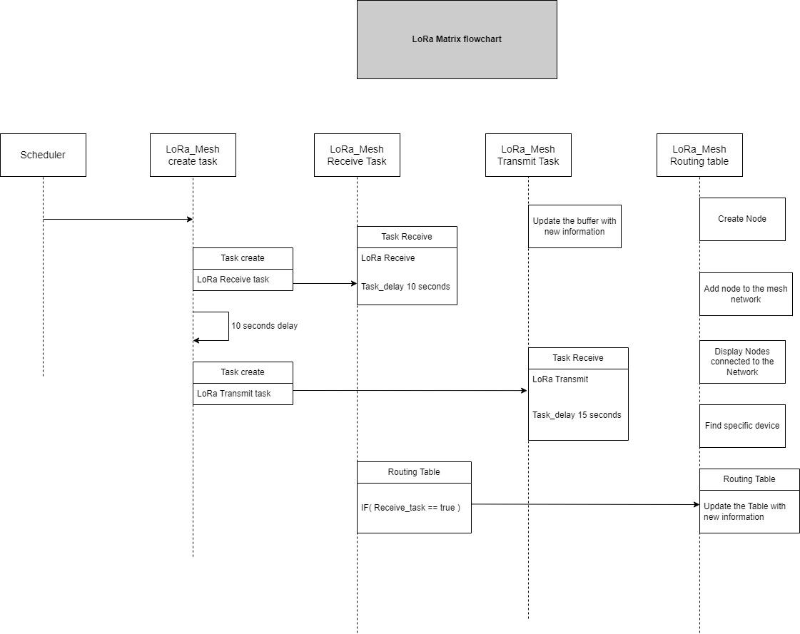

# 10. Reference documents

Datasheet of LLCC68_V1.0

ESP32-WROOM- 32E-H4

KXTJ3-1057

# 11. Problems in Current Technology

Mesh networking, while a promising technology for creating decentralized communication networks, faces several challenges such as scalability, power consumption, Routing complexity, network stability and self healing, Bandwidth limitations, security concerns, interference and range limitations.

Scalability:

As the number of devices in a mesh network grows, the complexity of managing and routing data increases exponentially. This leads to higher latency, congestion, and reduced efficiency in large networks.

Power Consumption:

In mesh networks, each device often acts as both a node and a router, constantly relaying data. This can significantly drain battery life, especially in wireless and IoT devices, where low power consumption is crucial.

Routing Complexity:

Efficient routing protocols are essential for the network to function well. However, maintaining optimal routes between devices can be computationally expensive, leading to delays and reduced performance.

Network Stability and Self-Healing:

While mesh networks are designed to self-heal by rerouting data if a node fails, this process can introduce instability and latency as the network tries to adjust dynamically.

Bandwidth Limitations:

With many devices communicating over the same network, bandwidth can become limited, causing congestion and slower data transmission.

Security Concerns:

Each node in a mesh network can be a potential point of vulnerability. Unauthorized access to one device can compromise the security of the entire network if not properly secured.

Interference and Range Limitations:

Wireless mesh networks can suffer from interference due to overlapping signals or external sources. Additionally, the range of communication is limited by the individual device's radio range.

# 12. Solution to the problems from this project

* Using both BLE and LoRa nodes for a mesh network, combining each network separately a hybrid system where BLE can handle local communication between closely positioned devices, while LoRa provides long-range communication. This can reduce the load on each individual network, allowing the mesh to scale more efficiently by offloading long-distance communication to LoRa and maintaining local connections with BLE.
* LoRa's long-range ensures that even if a few nodes fail, there’s often another node within range to maintain connectivity. BLE's ability to quickly form connections within a smaller area can also provide redundancy, so if a BLE node fails, others nearby can take over. Both protocols support self-healing mechanisms to reroute data when needed, improving network stability.
* BLE can synchronize devices within a close range, ensuring quick and reliable communication. LoRa devices can operate asynchronously, as the low data rate and long-range capability mean less frequent updates are required. Combining the two ensures that BLE can handle time-sensitive data exchanges locally, while LoRa handles longer-distance but less frequent communication.
* LoRa’s ability to operate over long ranges and in harsh environments with low interference ensures that the network remains connected over large distances. BLE, on the other hand, is optimized for low-range, high-frequency communication, which helps avoid interference by reducing the number of devices competing for the same radio frequencies in a given area.

# 